BOMBrowser

Table of Contents
1 Preface 2
2 Theory of operation 3
2.1 Revising a node 3
2.2 "Date from" / "date to" 4
2.3 BOM revisions 4
3 Browsing windows 7
3.1 Codes list window 7
3.1.1 Simple search 7
3.1.2 Edit menu 9
3.1.3 Search mode menu 10
3.1.4 Advanced search 10
3.2 Code context menu 12
3.3 Code properties panel 14
3.4 Shared windows menu 16
3.4.1 Windows menu 16
3.4.2 Help menu 16
3.4.3 File menu 17
3.5 Assembly window 18
3.5.1 File menu 19
3.5.2 Edit menu 19
3.5.3 View menu 20
3.5.4 Search menu 20
3.5.5 Export dialog 21
3.6 Where used window 22
3.7 Diff dialog 24
3.8 Special character for a search 26
3.9 Standard code properties 28
4 Editing window 28
4.1 Copy code dialog 28
4.2 Revise code dialog 30
4.3 Edit code dialog 31
4.3.1 Change of the children list 32
4.3.2 Change of the drawings 34
4.3.3 Change of the "date from" dates 35
4.3.4 Change the revision on which the dialog is operating 36
4.3.5 Menu edit 37
4.3.6 Menu import 37
5 Technical details 39
5.1 Configuration file 39
5.2 Database structure 39

Preface

BOMBrowser is a tool for managing technical BOMs, capable of describing a product from a technical point of view.
Initially, BOMBrowser was developed only to navigate BOMs; it was later extended to support BOM editing as well.
Navigation through BOMs is possible both from top to bottom (see the Show Assembly command family) and from bottom to top (see the Where Used command family). The former set of commands is useful for understanding how a product is composed, while the latter is used to understand where a component is (or has been) used. The results of these commands are indexed by date.
From BOMBrowser's point of view, a BOM is composed of a hierarchy of nodes linked to other nodes through parent-child relationships. A set of documents or links can be attached to each node. Each node has a number of attributes, such as:
- description
- date from / date to
- revision
- iteration
- …
The list of attributes can be extended by modifying the configuration file (see Chapter 5.1 - Configuration file for further information).

Theory of operation
As stated above, a BOM is a hierarchy of nodes connected through parent-child relationships.
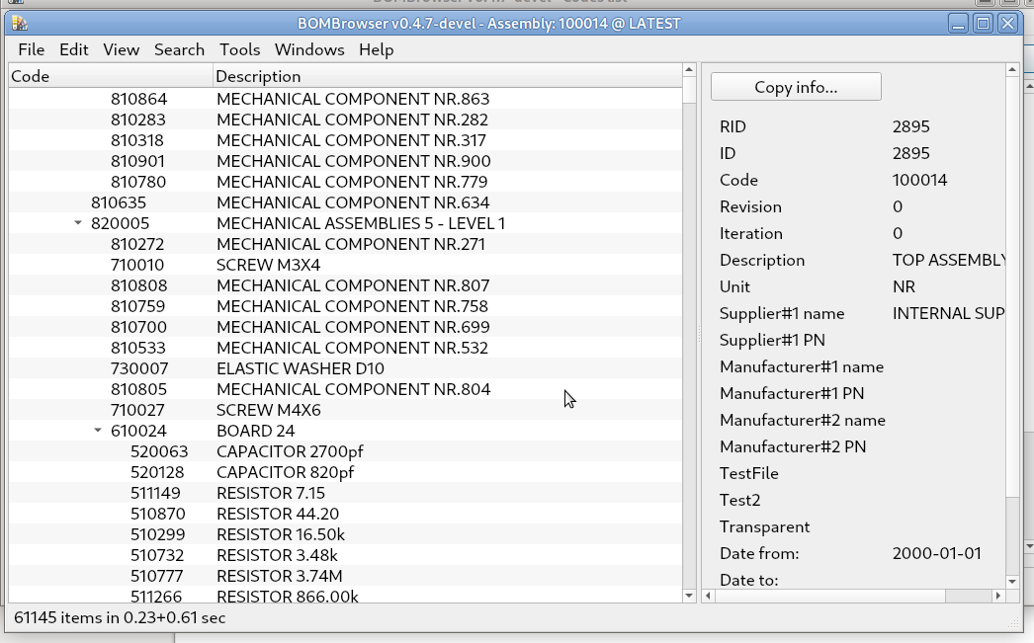
Each node has several attributes. The mains ones are:
- code
- description
- revision
- iteration
- "date from" / “date out” dates
- measure unit
- a list of children (the list may be empty)
- a list of attached documents/urls (the list may be empty)
Optionally, it is possible to configure further attributes attached to a node and/or to a child.
In a manufacturing process, a node of a BOM usually represent an assembly of its children or a purchase part. To a node is possible to attach documents (drawings, procedures, reports, technical specification) which describe the node (e.g. a drawing or a component specification) or the process that results in the node (e.g an assembling procedure).

Revising a node
To track changes over time, a node can be revised. A revision may consist of a change to any of the node's attributes (for example, changing its description or revision), a change to one of its children, or a change to an attached document. Some attributes cannot be changed, such as the code, which is fixed, and the iteration, which is managed by the system.
Whenever a node is revised, its iteration attribute is incremented. Usually, the revision attribute is used to identify the revision. However, from BOMBrowser's point of view, the revision is simply a text value attached to the node. The sequence of revisions is independent of the value of the revision attribute; what matters are the date from value and the iteration.
It is important to note that the relationship between a parent and its children is defined by the parent revision and the child code. The practical consequence is that a node revision is not tied to a specific BOM. If a user revises a node, all BOMs that reference that node see the new revision at the same time.
This reflects what happens in manufacturing processes, where a node represents a specific component that may be shared by multiple BOMs. A change to a component therefore affects all assemblies that use that specific component.

"Date from" / "date to"
Each revision of a node has a date from date and may have a date to date. These dates define the validity period of a specific revision. If multiple revisions of a node exist, the date to date of a revision is set to the day before the date from date of the next revision. The last revision may not have a date to date, meaning that its validity period has not yet ended.
It is possible to change the date from date of a revision. However, this also implies a change to the date to date of the previous revision.
An important rule regarding date from / date to dates and assemblies is that the children must exist for at least as long as the parent. Therefore, a child's initial date from date must be earlier than or equal to the date from date of the parent revision. Similarly, a child's final date to date must be later than or equal to the date to date of the parent revision.
This means that an assembly (the parent) can only be created if its components (the children) already exist.

BOM revisions
A BOM may be composed of thousands of nodes, each of which may have several revisions and different date from values.
This means that, for each date from value of each node, a different version of the BOM may exist. In fact, a BOM is identified by a top-level code and a date. For a given BOM date, only the node revisions whose date from / date to validity period includes that date are considered.
For example:
Node1:
- rev 0 (from 2020-01-10 to 2020-02-01), with children Node2, Node3, and Node4
- rev 1 (from 2020-02-02, with no date to), with children Node2 and Node3
Node2:
- rev 0 (from 2020-01-01 to 2020-01-15)
- rev 1 (from 2020-01-16, with no date to)
Node3:
- rev 0 (from 2020-01-01 to 2020-02-12)
- rev 1 (from 2020-02-13, with no date to)
Node4:
- rev 0 (from 2020-01-01 to 2020-02-01)
The nodes above have different revisions, resulting in four possible BOMs. The top-level code is always Node1, but the BOM date is different in each case.

Bom date validity | Tree
2020-01-10 … 2020-01-15 | Node1, rev0 | { | Node2, rev 0  Node3, rev 0  Node4, rev 0
2020-01-16 … 2020-02-01 | Node1, rev0 | { | Node2, rev 1  Node3, rev 0  Node4, rev 0
2020-02-02 … 2020-01-12 | Node1, rev1 | { | Node2, rev 1  Node3, rev 0
2020-02-13 ... | Node1, rev1 | { | Node2, rev 1  Node3, rev 1

Note that:
- Node4 has a date to date that is earlier than the date to date of Node1. However, Node4 is a child of Node1 revision 0 only, and the date to date of Node1 revision 0 is not later than the date to date of Node4.
- Node1, the top-level node, has only two revisions (rev 0 and rev 1). However, four different BOMs exist because the number of BOMs is determined by the different date from values.
- Each node is identified by a code and a revision, whereas a BOM is identified by a code and a date.
- In the example, the BOM is the same from 2020-01-01 to 2020-01-15.

Browsing windows
BOMBrowser was originally developed as a tool to navigate BOMs; only later was it extended to support editing and modifying BOMs.
The typical workflow is to search for a code and then find either its assembly (using the Show Assembly command family) or its parents (using the Where Used command family).
During this navigation, it is possible to edit any available node.

Codes list window
This is the first window that appears when the command is started. It allows the user to search for a code.

Simple search
This is the main window. It is used to perform simple searches in the list of codes. A new Codes List window can be opened at any time by pressing CTRL-L.
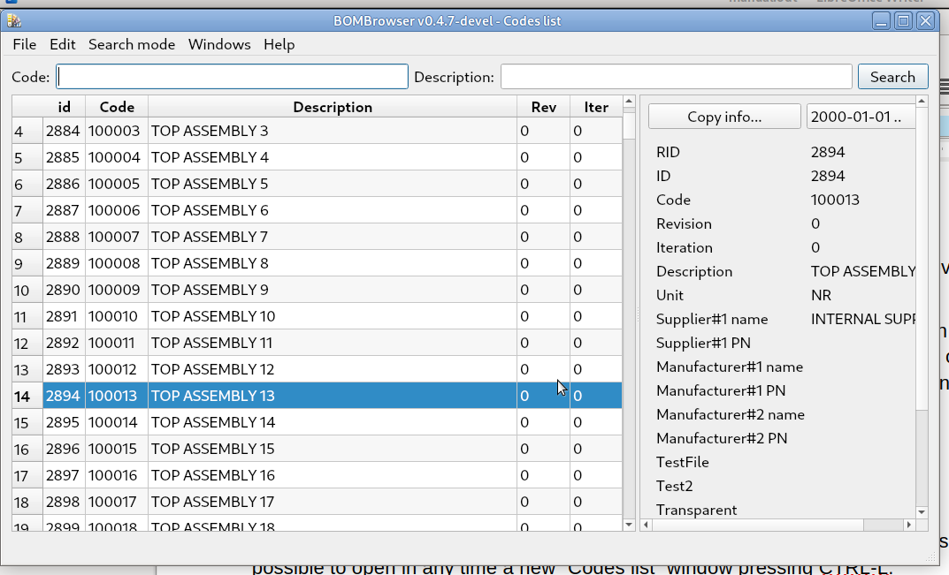
The most important part of the window is the left-hand section, which lists the available codes. For each code, the following information is displayed: Code, Description, Revision, and Iteration (of the latest revision).

On the right-hand side, there is the Code Properties panel, which displays the code properties and any attached documents or links. See Chapter 3.3 - Code properties panel for further information.

At the top of the window, there are two input fields for entering the Code and/or Description to search for codes.
By default, the window displays the codes that match both search fields.
A match occurs when the value entered in a field is a substring of the corresponding code or description. For example, if the Code field contains a specific string, all codes containing that string are returned.
Special characters can also be used to perform more advanced searches. See Chapter 3.8 - Special character for a search for further information.

Edit menu
The Edit menu allows the user to copy the table values to the clipboard. The fields are TAB-separated, and the rows are separated by a newline character.
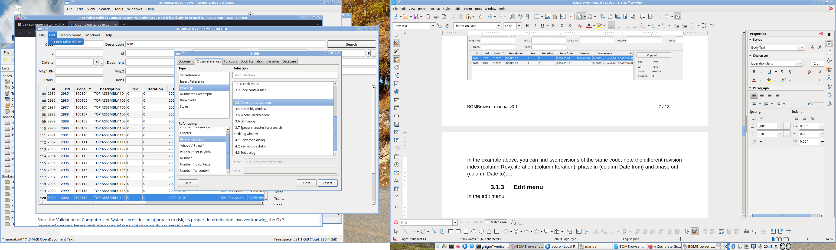

Search mode menu
The Search Mode menu allows the user to select the active search mode:
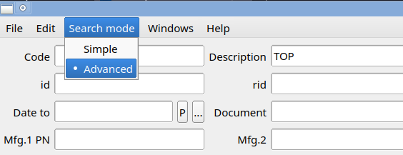
The Simple mode is the standard search mode. The Advanced mode is described in Chapter 3.1.4 - Advanced search.

Advanced search
It is possible to access to the Advanced search mode, selecting from the menu “Search mode” → “Advanced”
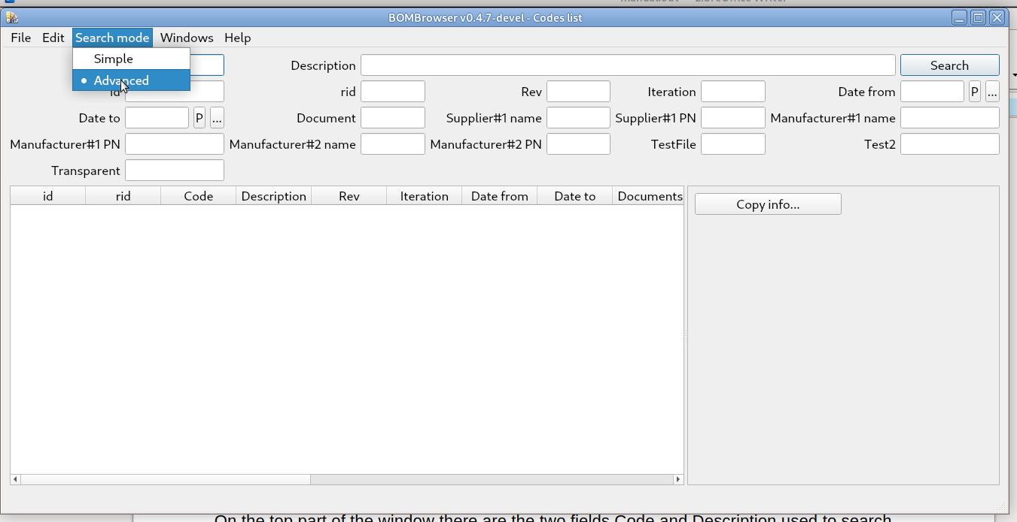
This mode allows users to search not only by code and description, but also by any other attributes. The rule is the same as for the Simple search: the results are the ones that match all the specified filters.
One of the key differences between the Simple and Advanced searches is that the former returns a list of code-and-description pairs, whereas the latter returns a list of code revisions. If a specific code has multiple revisions, all matching revisions are displayed.

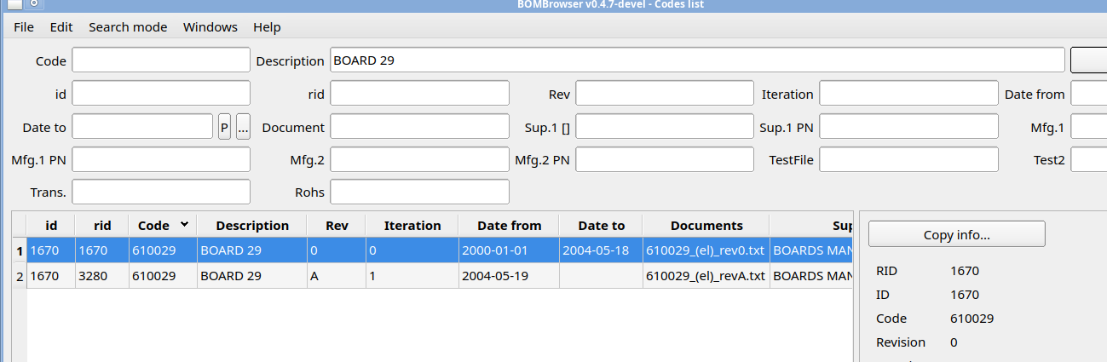
In the example above, you can see two revisions of the same code. Note the different revision indexes (the Rev column), iterations (the Iteration column), date from (the Date from column), and date to (the Date to column).

Code context menu
When the mouse pointer is over a row containing a code, right-clicking opens the code context menu:
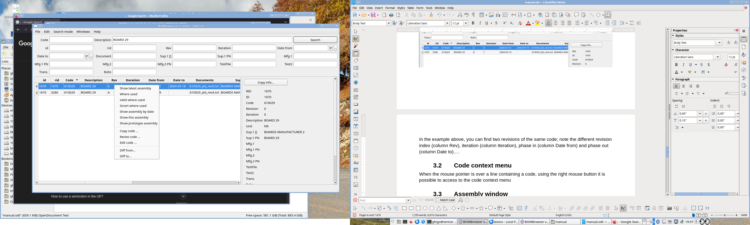
From this menu, the user can access the actions that can be performed on a specific code and/or revision. The available actions may vary depending on the context and on whether the database is writable or read-only.
The available actions are:
- Show latest assembly
This command shows the latest assembly (excluding the prototype) associated with a code. See Chapter 3.5 - Assembly window for further information.
- Show assembly by date
This command opens a dialog box where the user can select any of the available BOMs indexed by date. See Chapter 3.5 - Assembly window for further information.
- Show this assembly
This command shows the specific BOM associated with the selected revision of the code, based on its date from value. See Chapter 3.5 - Assembly window for further information.
- Show prototype assembly
This command shows the prototype BOM associated with the code. See Chapter 3.5 - Assembly window for further information.
- Where used
This command shows where (and when) a code is used. See Chapter 33.6 - Where used window for further information.
- Valid where used
This command shows where (and when) a code is used. However, it considers only the latest revision without a date to value. This is useful for determining where a component is currently used in active products. See Chapter 3.6 - Where used window for further information.
- Smart where used
This command shows where (and when) a code is used. However, it considers only the latest revision without a date to value and shows only the searched code, the assembly containing the code, and the top-level code representing the product. See Chapter 3.6 - Where used window for further information.
- Copy code
This command is used to copy a code. See Chapter 4.1 - Copy code dialog for further information.
- Revise code
This command is used to revise a code. See Chapter 4.2 - Revise code dialog for further information.
- Edit code
This command is used to edit or delete a code. See Chapter 4.3 - Edit code dialog for further information.
- Diff from … / Diff to …
These commands are used to compute the differences between two specific revisions. See Chapter 3.7 - Diff dialog for further information.

Code properties panel
In some windows, such as Assembly, Where Used, and Codes Search, the right-hand panel is called the Code Properties panel.
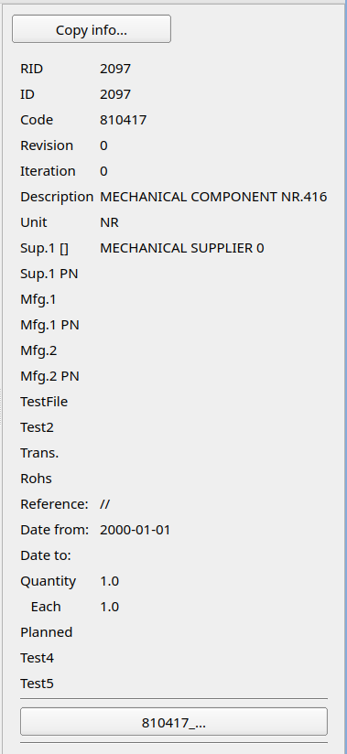
This panel displays all the metadata associated with a code. In the bottom section of the panel, the documents or URLs attached to the specific revision are listed.
Clicking the left mouse button on a document button opens the document.
Clicking the right mouse button opens a context menu that provides the following options:

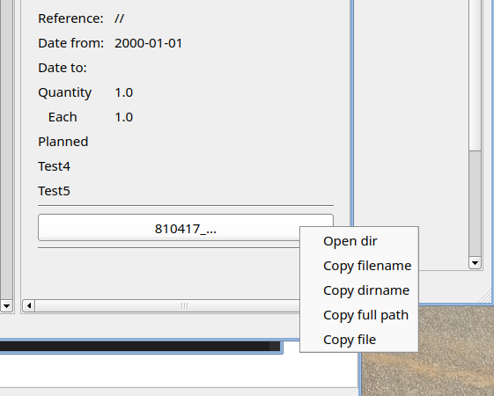
The context menu for a document provides the following options:
- Open dir: opens the directory where the file is stored.
- Copy filename: copies the filename to the clipboard.
- Copy dir name: copies the name of the directory where the file is stored to the clipboard.
- Copy full path: copies the full path of the file to the clipboard.
- Copy file: copies the file to the clipboard.
Clicking the left mouse button on a URL button opens the URL, typically in a web browser.
Clicking the right mouse button opens a context menu that provides the following options:

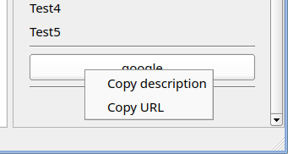

The context menu for a URL provides the following options:
- Copy description: copies the description text to the clipboard.
- Copy URL: copies the URL to the clipboard.
At the top of the panel, there is a Copy info... button.
The Copy info... button copies the attributes displayed in the panel to the clipboard.
If the panel is associated with a code, the top-left section contains a list box that allows the user to select the revision to display. Revisions are indexed by date.

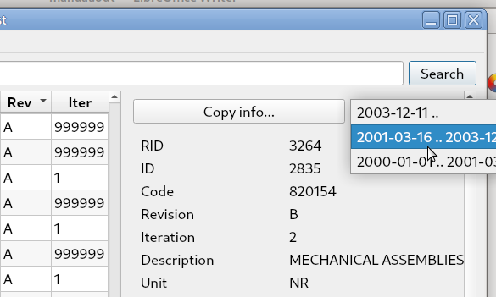

Shared windows menu
Each window has its own set of menus. However, some menus are common to multiple windows. This chapter describes the common menus.

Windows menu
This menu is available in every window. It allows the user to select and bring a window to the foreground.
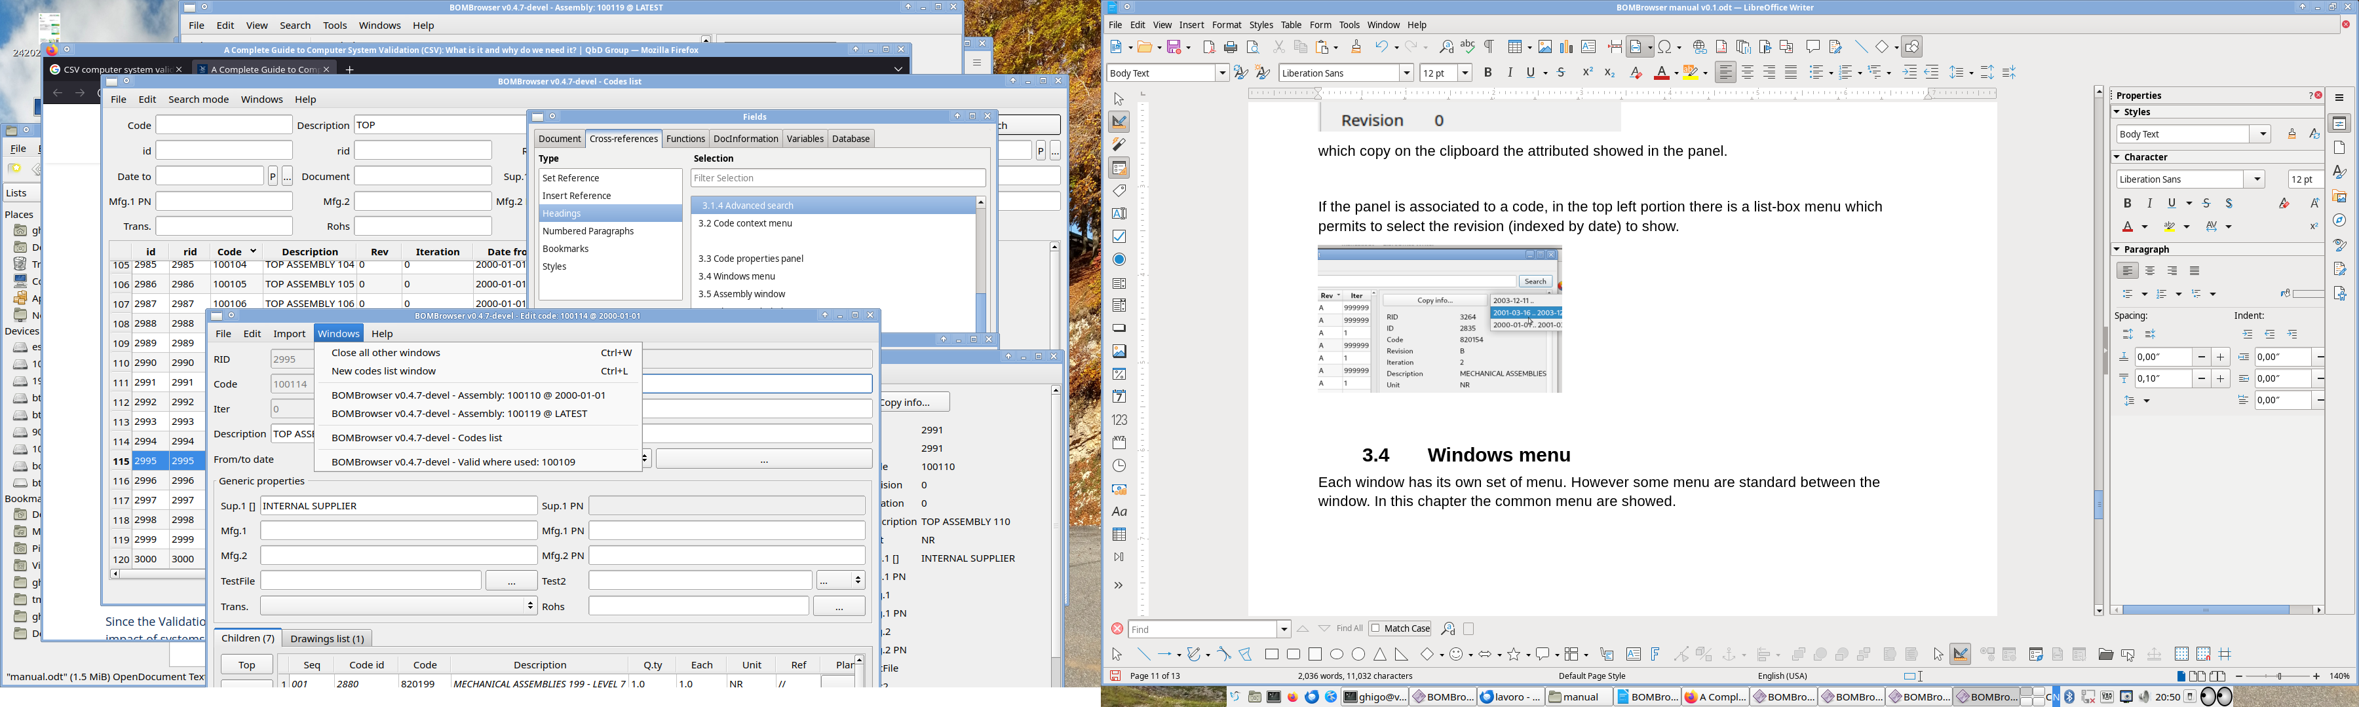
It is also possible to close all other windows except the active one (CTRL+W), or to open a new Code List window (CTRL+L).

Help menu
With this menu
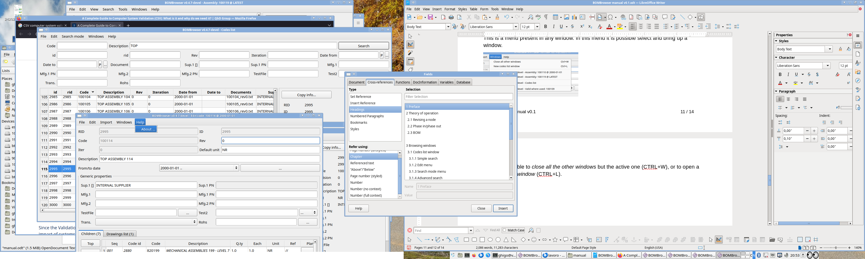
it is possible to show the about dialog.
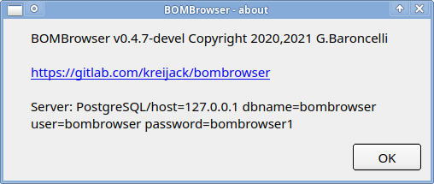

File menu
The File menu is specific to each window. However, every File menu contains, at a minimum, a common set of commands:
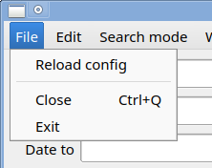
- Reload config: reloads and applies the configuration file.
- Close: closes the current window.
- Exit: exits BOMBrowser.

Assembly window
The assembly window, shows a BOM
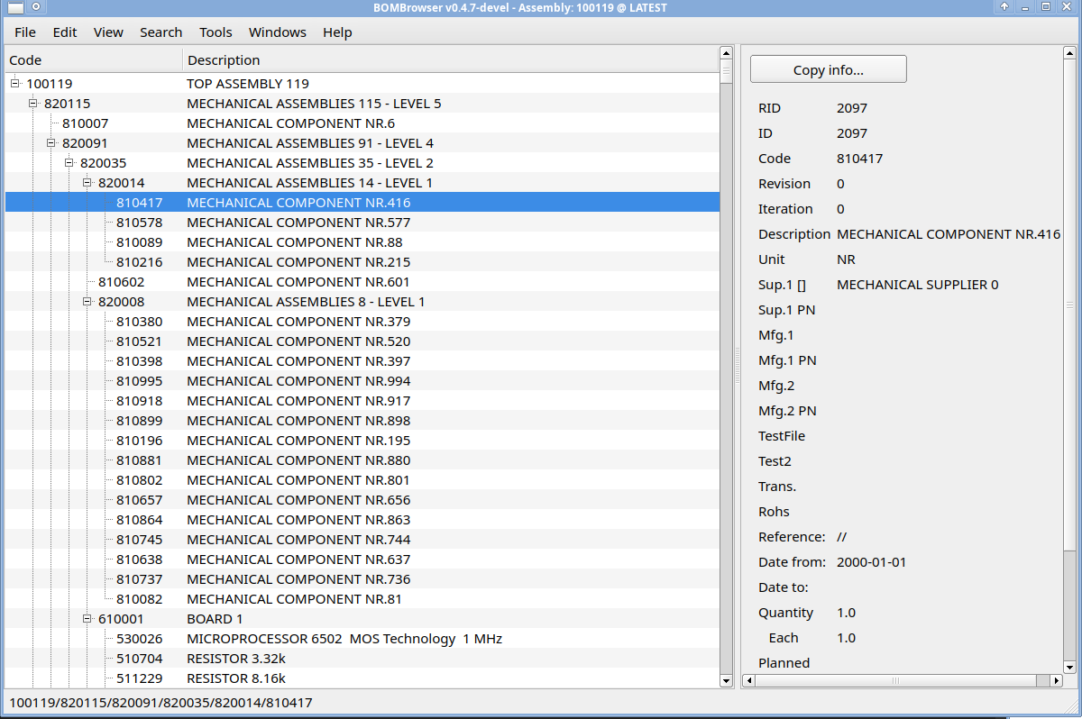

The left panel contains the tree where the user can select a specific code. On the right, there is the Code Properties panel, which displays the code properties and any attached documents. See Chapter 3.3 - Code properties panel for further information.
The window title indicates which BOM is being displayed, in terms of the top-level code and date (or LATEST).

File menu
The file menu
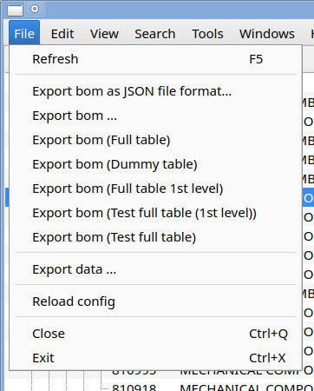
The File menu contains the following commands:
- Refresh: refreshes the assembly. This is useful when the user is editing a code in another window.
- Export BOM...: exports the displayed BOM in different formats. The available formats are configured in the configuration file.
- Export data...: opens the export dialog. See Chapter 3.5.5 – Export Dialog for further information.

Edit menu
The edit menu
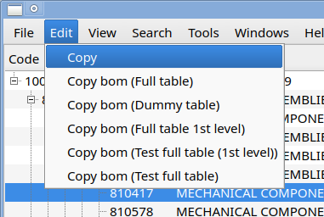
The Edit menu contains the Copy command, which copies the BOM to the clipboard.
Different BOM formats are available and can be configured in the configuration file. See Chapter 5.1 - Configuration file for further information.

View menu
The view menu
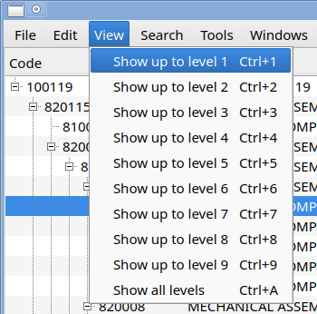
sets the depth of the BOM to be displayed.
Selecting “Show up to level 2”, in the tree windows only the first two levels are showed. | 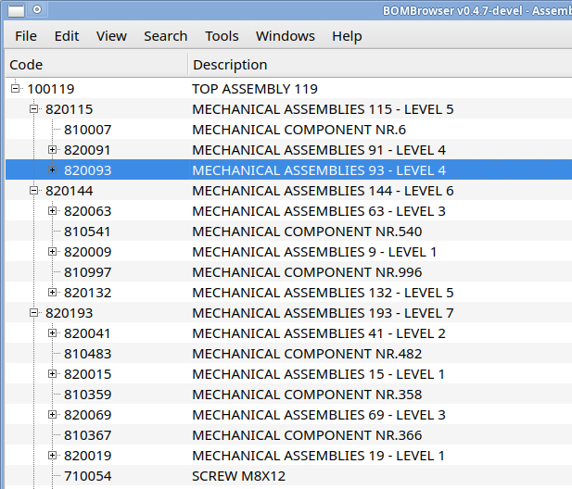
Selecting “Show all levels”, in the tree windows all the levels are showed. | 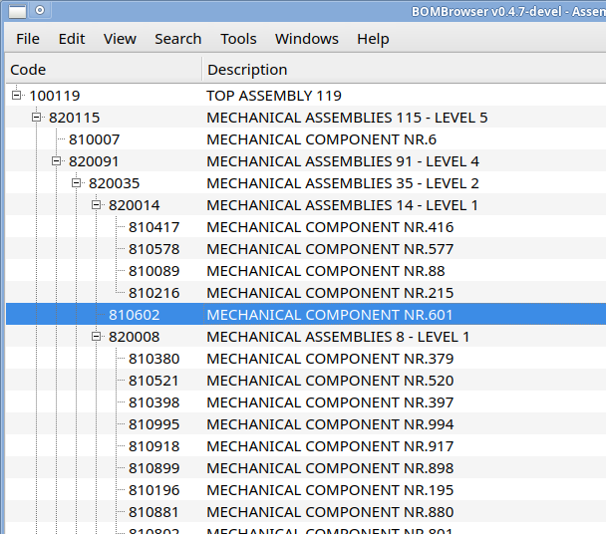

Search menu
The search menu
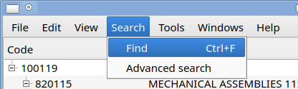
has two commands:
- Find: shows a dialog to search inside the BOM
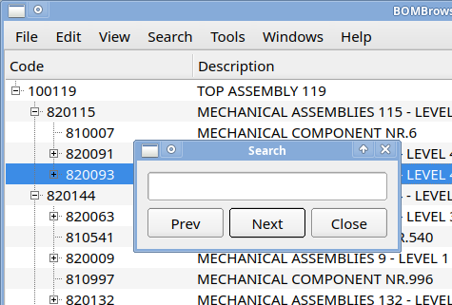
pressing prev and next it is possible to search forward and backward in the bom.
- Advanced search: open a Search in bom window, which acts like the Advanced search window but it searchs only inside the BOM.
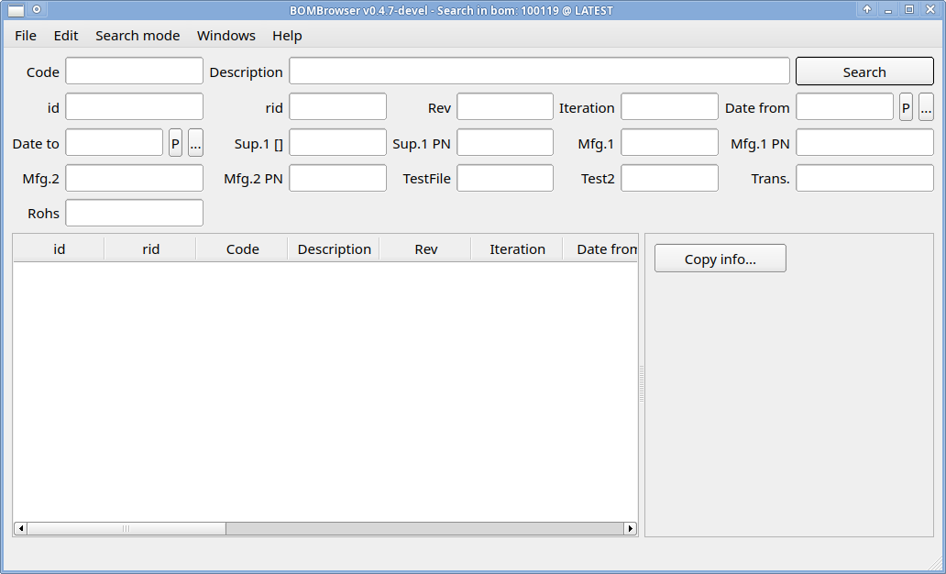

Export dialog
The export dialog
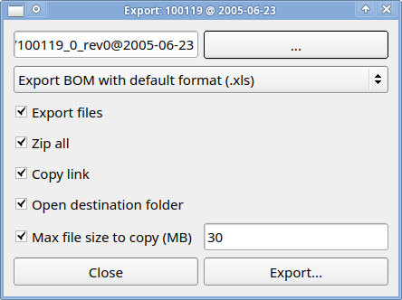
exports the BOM with all the documents attached. The “…” button allow to set the directory where the data will be stored.

This button
allows to select a different format for the BOM. This is configured in the configuration file (see chapter 5.1 - Configuration file for further information).
For the export the following options are available:
- Export files: all the files attached to the node of the BOM are exported.
- Zip all: after the export all the files are zip-ed togher.
- Copy link: the link of the directory (or the of zip file if the option is enabled), it is copied in the clipboard after the export.
- Open destination folder: after the export the destination folder is opened
- Max file size to copy: allows to set a maximum file size to export (e.g. a file bigger than this limit is not exported).

Where used window
The Where Used window is very similar to the Assembly window. The main difference is that the Assembly window displays the BOM from the top-level code down to the leaf components, while the Where Used window displays the BOM starting from a leaf component and showing all the possible top-level codes.
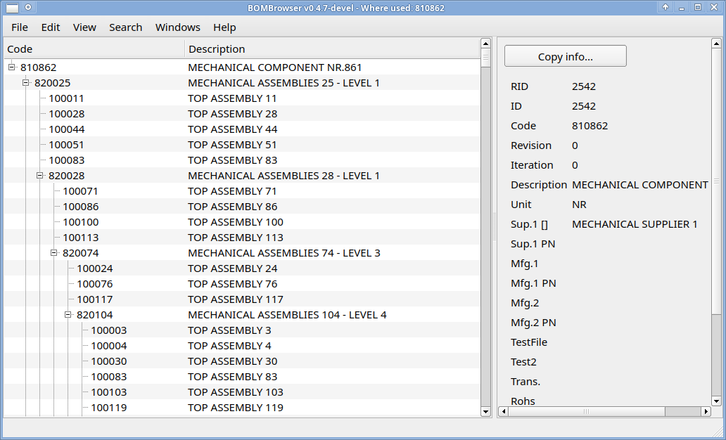

If a code is contained in two revisions of a parent code, both revisions are displayed in the tree panel.
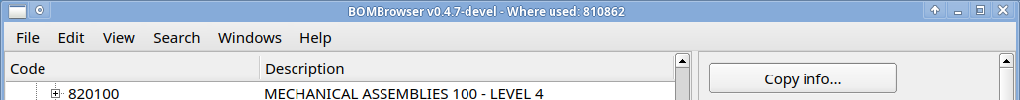
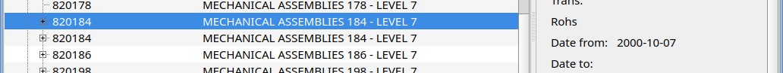
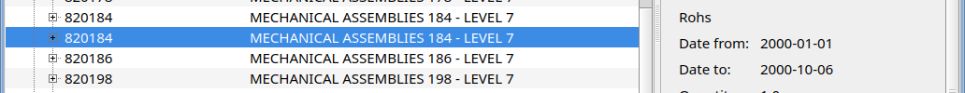

In the example above, code 820148 appears twice. The first instance is a revision with a date from of 2000-10-07. The second instance has a date from of 2000-01-01 and a date to of 2000-10-06.
The Where Used window provides three different variants:
- Standard — the code is searched across all possible products.
- Valid Where Used — the code is searched only within valid items, i.e., items without a date to.
- Smart Where Used — the code is searched only within valid items, and the BOM is displayed partially: only the first assembly level and the top-level code are shown.

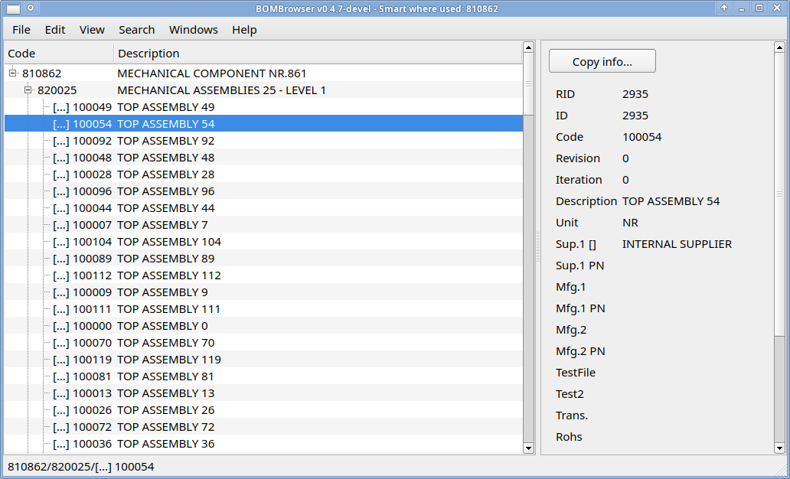

Diff dialog
The Diff dialog allows you to compare two BOMs. To perform the comparison, you must select two different revisions. To do this, you start the Diff from command from a specific code (e.g. from the Code list window):
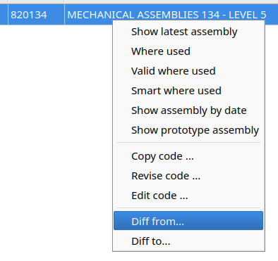
After that, a dialog allowing you to select a specific date will appear:
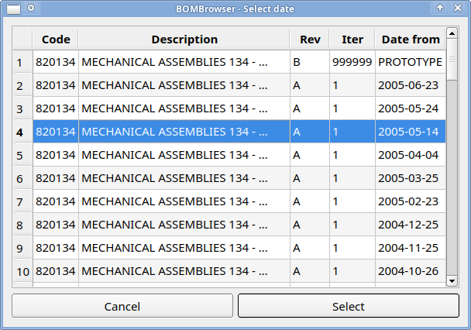
After a date is selected, another dialog will appear.
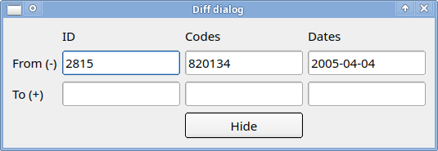
The From (–) row shows which BOM (identified by a code and a date) is the starting point for computing the difference. After that, repeat the same action with the Diff to command on a code (for example, from a Codes List window).
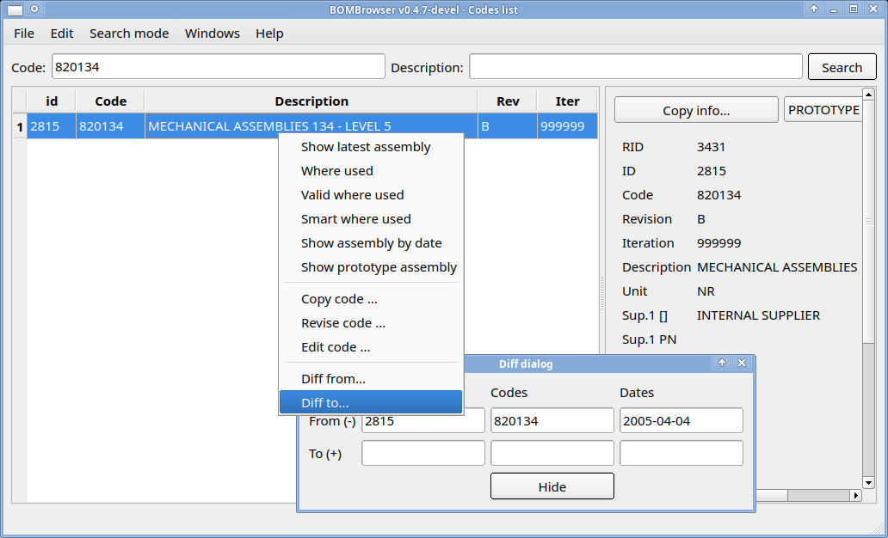

Again, a dialog for selecting a specific date will appear, allowing the user to choose a target point for computing the difference.
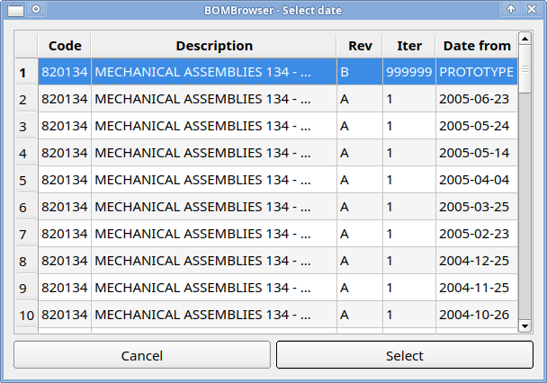
Then a window with the results will appear
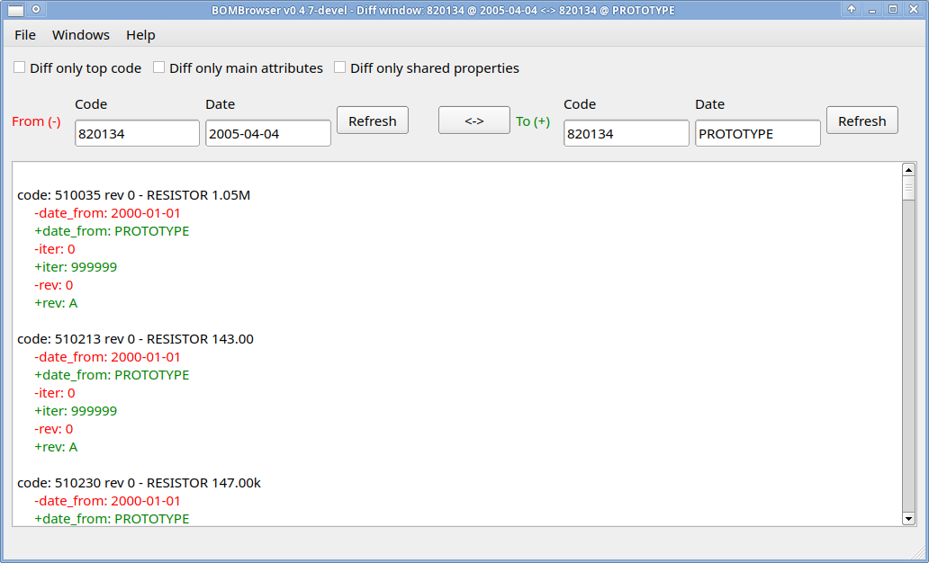
This output window contains the removed codes (marked in red), the added codes (marked in green), and the changed properties (with old values in red and new values in green). The purpose is to describe the changes that must be applied to the From BOM in order to reach the state of the To BOM.
The BOMs being compared may have different top-level codes.
Note: if the user starts the Diff from / Diff to commands from a specific revision (for example, by selecting the revision from the Advanced Search window, which displays only the revisions of a code), the Select Date dialog will not appear and the revision will be detected automatically.

Special character for a search
In the Codes List window and in the Search in BOM window, special characters can be used to build powerful queries:
- ‘%’ (percent) — matches any sequence of characters.
- ‘_’ (underscore) — matches any single character.
- ‘=’ (equal) — matches exactly the string that follows.
- ‘;’ (semicolon) — separates two queries and means the query before ‘;’ OR the query after ‘;’.
Examples:
- 123% — any sequence of characters starting with 123.
- 123 — any sequence of characters containing 123.
- %123 — any sequence of characters ending with 123.
- 12__45 — any sequence composed of 12, followed by any two characters, followed by 45.
- 123%;456% — any sequence starting with 123 OR starting with 456.
- 123;456 — any sequence containing 123 OR containing 456.
- =678%9;987 — any sequence exactly equal to 678%9;987.
- ;=678%9;987 — any sequence exactly equal to 678%9 OR containing 987.
Note:
- If ‘;’ is the first character, it is treated as a separator between different query sets.
- If ‘=’ is the first character, then ‘;’ (and any other special character) is treated as a normal character.
- If no special character is used, then the match is successful if the string contains the sequence

Standard code properties
Each node has a minimum set of properties:
Property name | Meaning
code | The code that represent a node. It is a constant between the revisions.
revision | The revision of the node. It is a free text.
iteration | The number of the iteration of a node. The iterations may be not consecutive (e.g. a revision might be canceled), but the revisions are ordered on the basis of the iteration.  If a new revision is generated the iteration of the new revision is equal to the iteration of the previous one + 1.
description | The description associated to a node.
unit | The measure unit of a node.
"date from" | The "date from" when the revision is valid.
"date to" | The "date to" when the revision is valid.
RID | Revision ID, an internal number that represent a specific revision.
ID | (Code) ID, an internal number that represent a specific code.

Further properties may be configured in the configuration file (see chapter 5.1 - Configuration file for further information).

Editing window

Copy code dialog
The Copy Code command is used to duplicate an existing code. This is the only way to create a new code, since an empty database always contains at least one initial code. When the user starts the Copy Code command from a specific code, the Select Date dialog will appear.

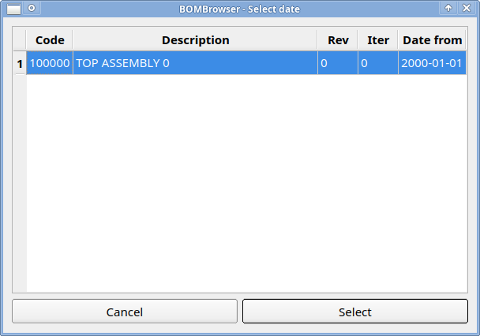
With this dialog, you can select a specific revision of the code from which the new code will be copied. After that, the following dialog will appear:
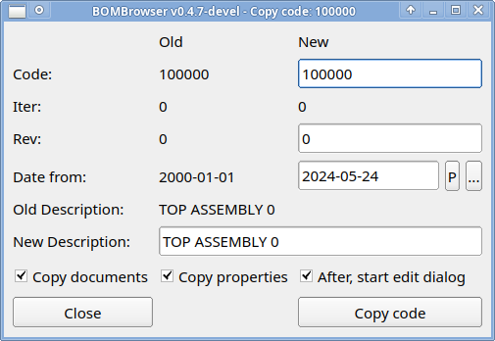
In this dialog, you can modify the following fields:
- New code — an error is raised if this code already exists.
- Date from (Phase-in date).
- Initial revision.
- New description.
In the lower part of the dialog, there are three check boxes:
- Copy document — if selected, the link to the document is copied into the new code.
- Copy property — if selected, the properties are copied into the new code.
- After, start edit dialog — if selected, the Edit Code dialog will appear immediately after the code is copied.

Revise code dialog
The Revise Code command is used to create a new revision of an existing code. When the user starts the Revise Code command from a specific code, the Select Date dialog will appear.
With this dialog it is possible to select a specified revision of code from which the new revision will be copied. After that the following dialog will appear:
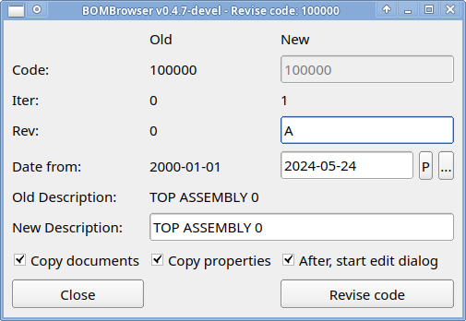
In this dialog, you can modify the following fields:
- Date from (Phase-in date).
- New revision.
- New description.
In the lower part of the dialog, there are three check boxes:
- Copy document — if selected, the link to the document is copied into the new revision.
- Copy property — if selected, the properties are copied into the new revision.
- After, start edit dialog — if selected, the Edit Code dialog will appear immediately after the revision is created.

Edit code dialog
The Edit dialog is the main interface for modifying a node. The possible changes include:
- Description — updating the textual description of the node.
- Revisions — changing the revision associated with the node.
- Default unit — selecting a different default unit of measure.
- Date from — modifying the phase-in dates.
- Children — adding, removing, or updating child nodes.
- Generic properties — editing the configurable properties defined in the configuration file (see chapter 5.1 - Configuration file).

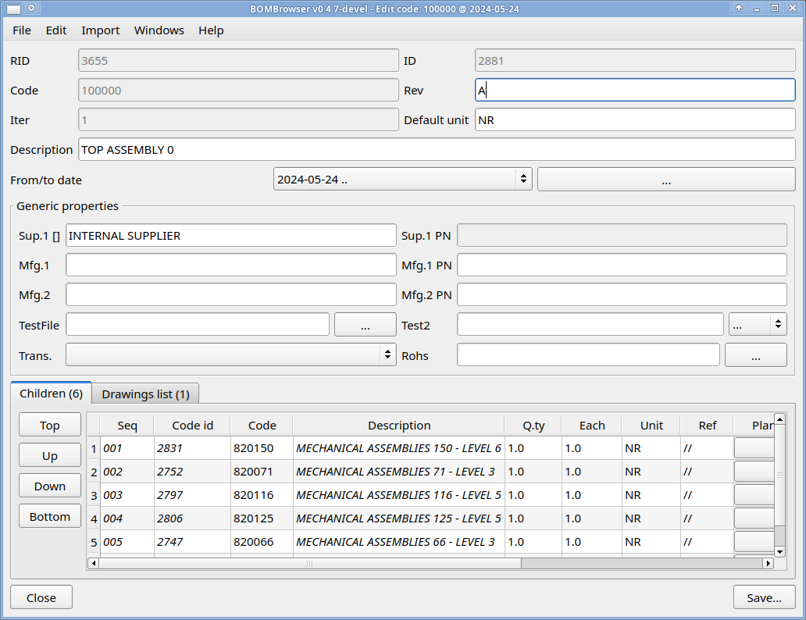
If the user exits the form after making changes, a dialog will ask whether the data should be saved before switching to the new revision.
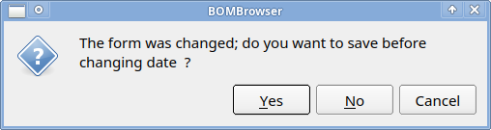

Change of the children list
In the lower part of the Edit code dialog, there is the children list.

It is possible to change the sequence of the children by selecting one or more rows and pressing the following buttons:
- TOP — moves the selected row(s) to the top position.
- UP — moves the selected row(s) up by one position.
- DOWN — moves the selected row(s) down by one position.
- BOTTOM — moves the selected row(s) to the bottom position.
By pressing the right mouse button, it is possible to access a context menu.

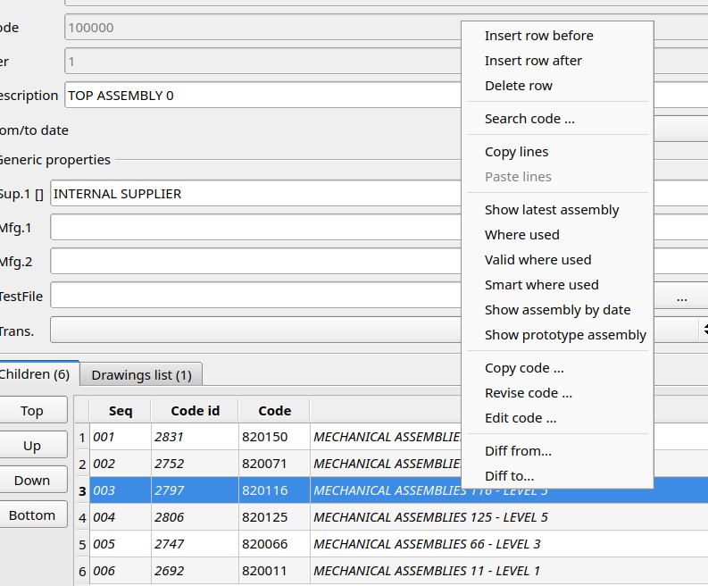
…that allows access to the standard commands (see chapter 3.2 - Code context menu) and to specific commands such as:
- Insert row before — inserts an empty row before the selected one.
- Insert row after — inserts an empty row after the selected one.
- Delete row — deletes the selected row(s).
- Search code

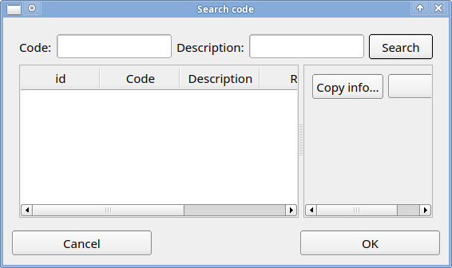

- Copy lines — copies the selected lines into the BOMBrowser memory.
- Paste lines — pastes previously copied lines from the BOMBrowser memory.

On each row, it is possible to modify the following fields:
- Code — the identifier of the child node.
- Q.ty — the quantity of the child.
- Each — the “each” value associated with the child.
- Unit — the unit of measure; by default, this field is filled with the default unit of the child code.
- Ref(erence) — the reference associated with the child.
- Additional fields — further fields configured in the configuration file (see chapter 5.1 - Configuration file).

Change of the drawings
By selecting the Drawings List tab, you can view and open the document attached to the node.
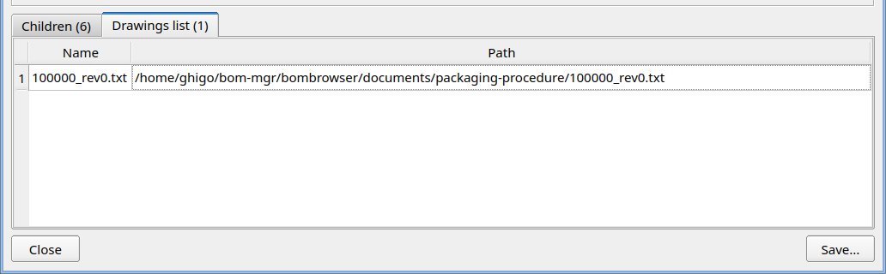
By double-clicking the line, you can view the attached document. By pressing the right mouse button, you can access a context menu.
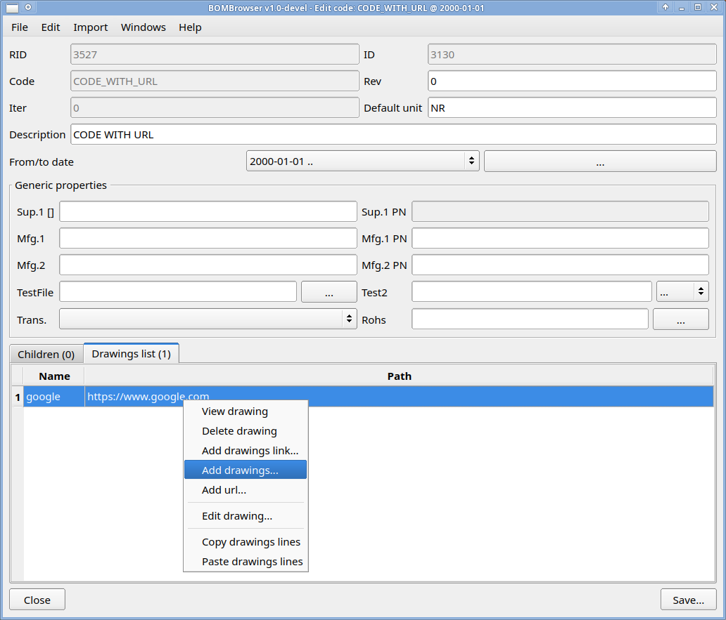
…which allows:
- View drawing — views the selected document.
- Delete drawing — deletes the selected document(s).
- Add drawing link — links an existing document to the node.
- Add drawing — attaches a new document to the node.
- Add URL — attaches a URL to the node.
- Copy drawings lines — copies the selected line(s) into the BOMBrowser memory.
- Paste drawings lines — pastes previously copied line(s) from the BOMBrowser memory.
A drag-and-drop action attaches a new document to the node.

Change of the "date from" dates
Using the button showed below
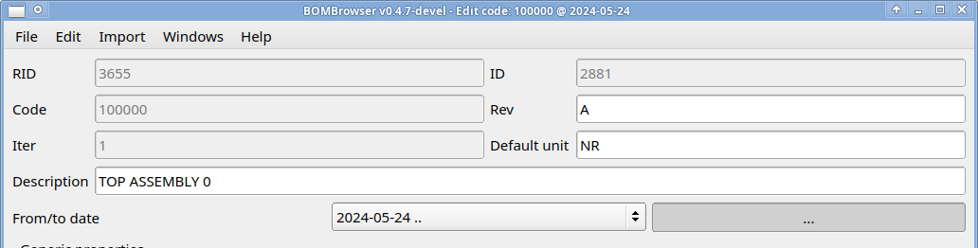
It is possible to open a dialog that allows changing the “date from” values of the code revisions.
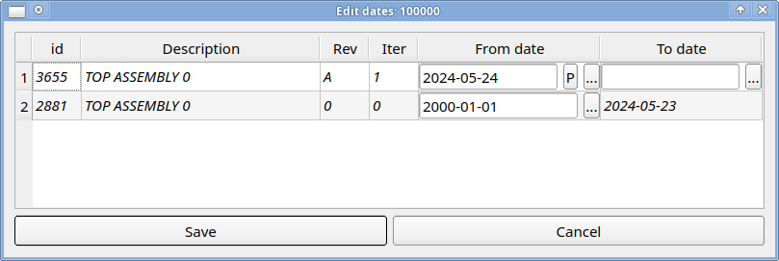

In this dialog, each line represents a specific revision, and it is possible to modify its “date from” value. For the latest revision, it is also possible to modify the “date to” value.
Pay attention: changing the first “date from” value or the latest “date to” value may violate the rule that a child node must outlive the parent node. In this case, when the user attempts to save, the following dialog will appear.

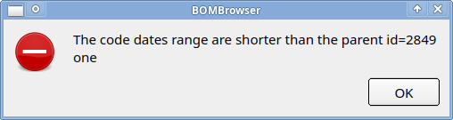
(To find the correct parent, search for a code with an ID equal to the one shown in the dialog.)
Another possible issue occurs when the “date from” values are not in the same chronological order as the revisions. In this case, an error dialog will also appear when the user attempts to save.

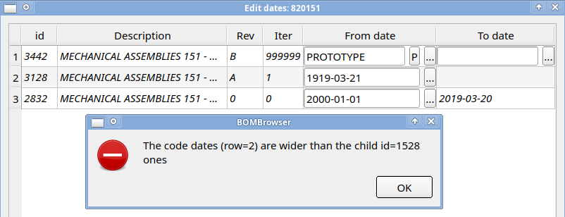

Change the revision on which the dialog is operating
Using the list-box menu shown below, it is possible to access a selection dialog that allows choosing the desired revision date.
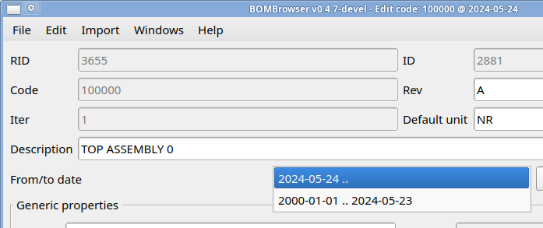
…so it is possible to select a different revision of the code to modify. If changes have already been made, a dialog will ask whether the data should be saved before switching to the new revision.

Menu edit
The menu edit
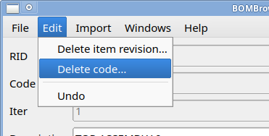
The dialog provides the following commands:
- Delete item revision — removes the currently selected revision.
Note: when a revision is removed, the dates are automatically rearranged so that the first “date from” and the last “date to” remain unchanged.
- Delete code — removes the code together with all its revisions.
Note: if the code is used in another assembly, it cannot be deleted. The user must first remove the code from all parent revisions.
- Undo — reverts all changes to their initial state.

Menu import
The Import menu is a custom menu (configured through the configuration file; see chapter 5.1 - Configuration file) that allows importing data from an external source.

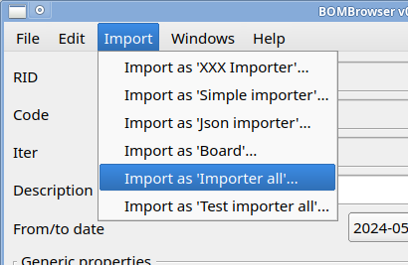

Technical details

Configuration file
When BOMBrowser starts, it reads the configuration file named bombrowser.ini, located in the same folder as the executable. This file uses a standard .ini format; refer to the comments inside the file for the meaning of each property.
If a file named bombrowser.forward exists in the executable folder, its content is used as the path to the .ini file that BOMBrowser will load.

Database structure
The database is composed of four main tables:
- Items
- Item_revisions
- Assemblies
- Drawings
The Items table contains the codes. Each code is unique within this table.
The Item_revisions table contains the revisions. Each revision is linked to a code in the Items table. Multiple revisions may refer to the same code; in this case, each entry represents a different revision of that code. A revision contains all the information of a node, such as description, units, revision text, iteration, “date from”, “date to”, and other properties.
Revisions are ordered by iteration. For each iteration, the “date to” of iteration n-1 is equal to the “date from” − 1 of iteration n. Iteration numbers may not be consecutive.
The Assemblies table contains the link to a specific revision and the link to its children. A child is identified by its code. The BOM date determines which revision of the child must be considered.
The Drawings table contains the link to a specific revision and the path of a document. Documents are stored in a directory (typically a shared folder). In addition to file paths, this table may also contain URLs (http://, https://, ftp://).

Below is a simplified definition of the tables using SQL syntax.
CREATE TABLE items (
id INTEGER NOT NULL IDENTITY PRIMARY KEY,
code VARCHAR(255) NOT NULL
);

CREATE TABLE item_revisions (
id INTEGER NOT NULL IDENTITY PRIMARY KEY,
code_id INTEGER,
date_from_days INTEGER DEFAULT 0, -- 2000-01-01
date_to_days INTEGER DEFAULT 999999,
ver VARCHAR(10) NOT NULL,
iter INTEGER,
type VARCHAR(255),
note VARCHAR(255),
descr VARCHAR(255) NOT NULL,
default_unit VARCHAR(10) NOT NULL,

-- further properties if configured

FOREIGN KEY (code_id) REFERENCES items(id)
);

CREATE TABLE assemblies (
id INTEGER NOT NULL IDENTITY PRIMARY KEY,
unit VARCHAR(10),
child_id INTEGER,
revision_id INTEGER,
qty FLOAT,
each FLOAT DEFAULT 1.0,
ref VARCHAR(600) DEFAULT '',

-- further properties if configured

FOREIGN KEY (child_id) REFERENCES items(id),
FOREIGN KEY (revision_id) REFERENCES item_revisions(id)
);

CREATE TABLE drawings (
id INTEGER NOT NULL IDENTITY PRIMARY KEY,
code VARCHAR(255) DEFAULT '',
revision_id INTEGER,
filename VARCHAR(255) NOT NULL,
fullpath VARCHAR(255) NOT NULL,

FOREIGN KEY (revision_id) REFERENCES item_revisions(id)
);

The relation between the tables are enforce with “foreign key”, where possible.
The fields date_from_days/date_to_days measure the date in term of day from 2000-01-01:
Date_from_days/Date_to_days | Date (YYYY-MM-DD)
0 | 2000-01-01
-100 | 1999-09-23
400 | 2001-02-04
999900 | Prototype
999999 | No date

Prototype date and “no date” are fixed values, respectably 999900 and 999999.

